**SQL Lesson 1: SELECT queries 101**

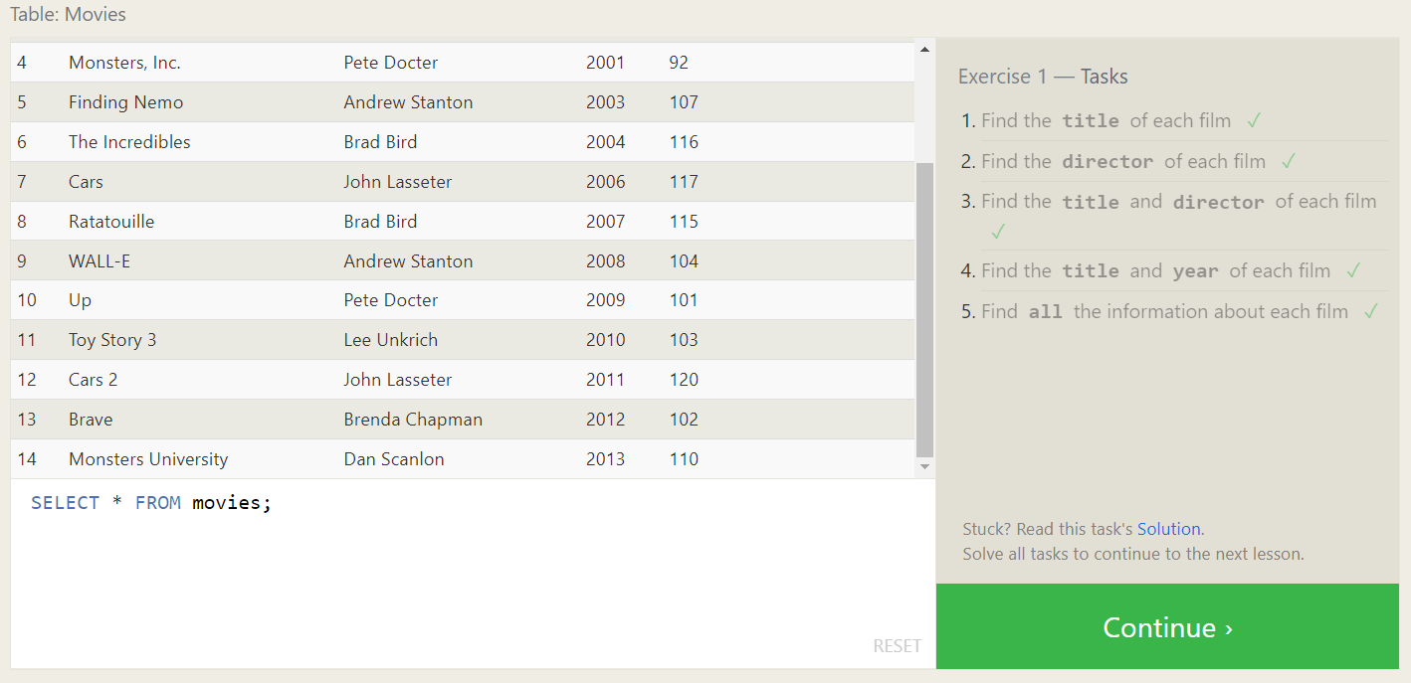

Exercise 1 — Tasks

**SQL Lesson 2: Queries with constraints (Pt. 1)**

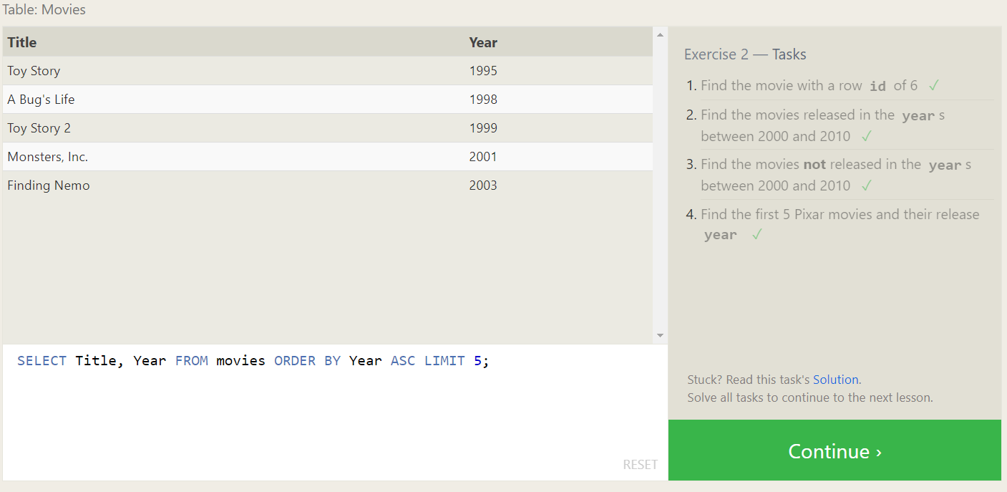

Exercise 2 — Tasks

**SQL Lesson 3: Queries with constraints (Pt. 2)**

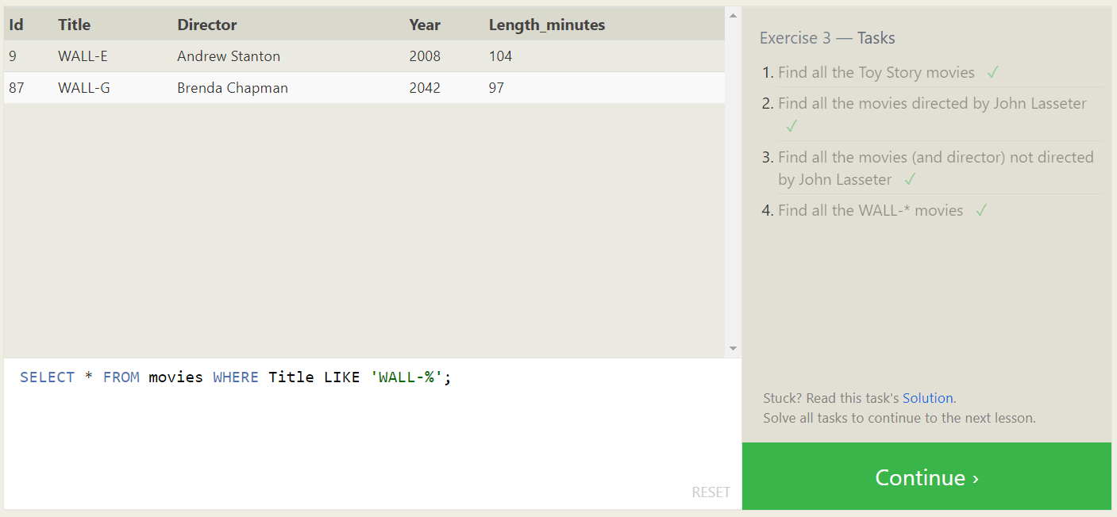

Exercise 3 — Tasks

**SQL Lesson 4: Filtering and sorting Query results**

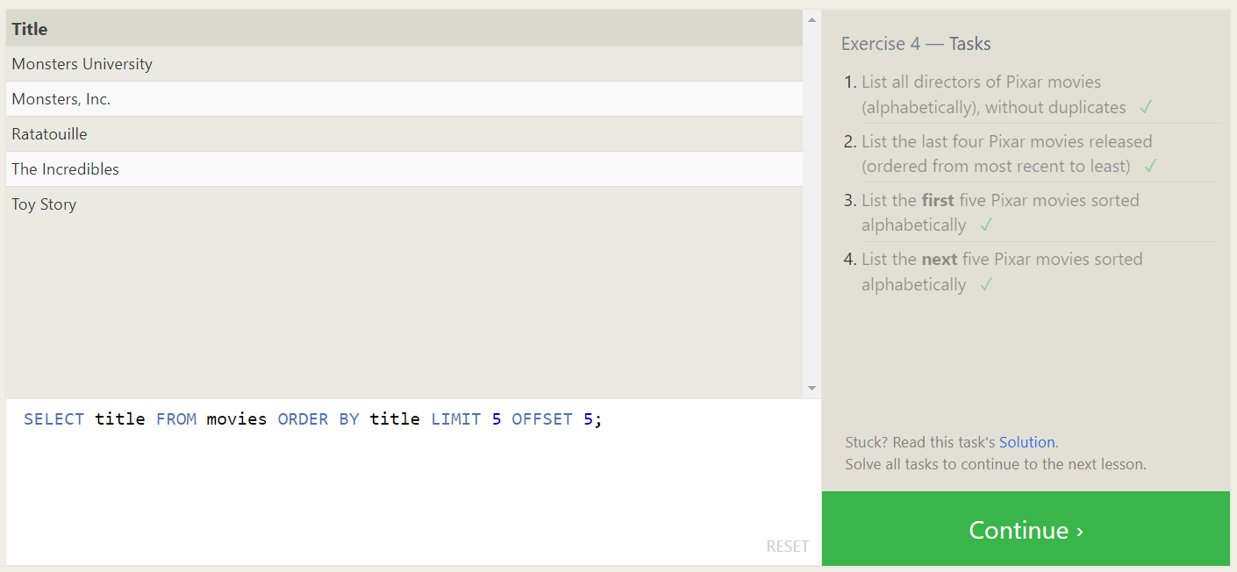

Exercise 4 — Tasks

**SQL Review: Simple SELECT Queries**

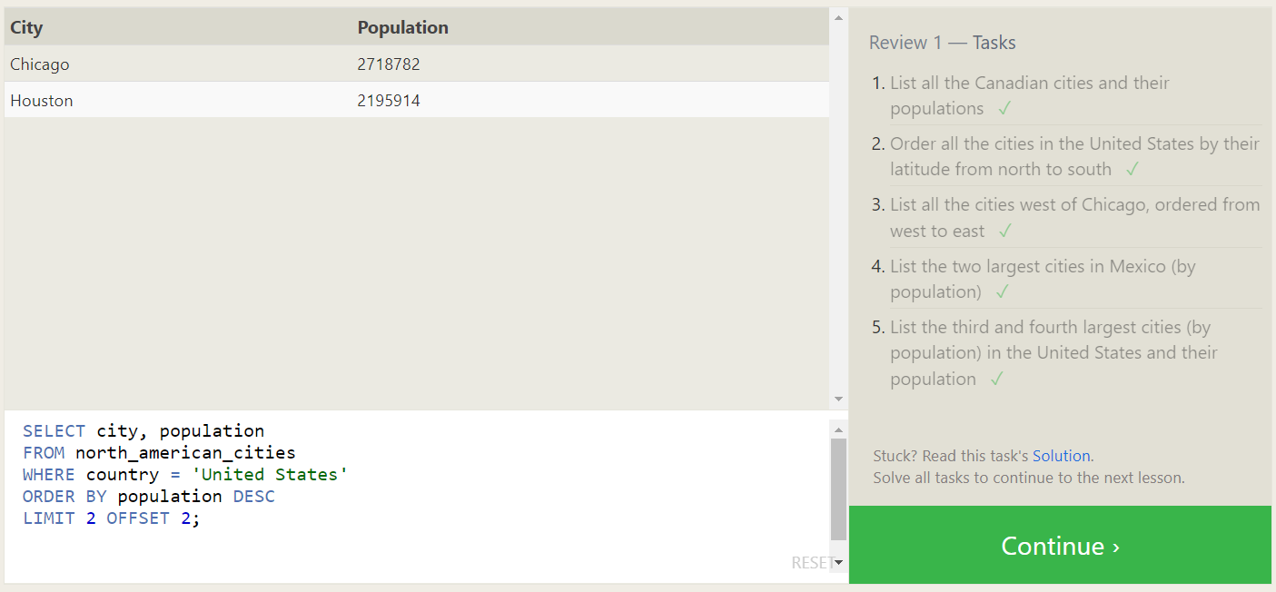

Review 1 — Tasks

**SQL Lesson 6: Multi-table queries with JOINs**

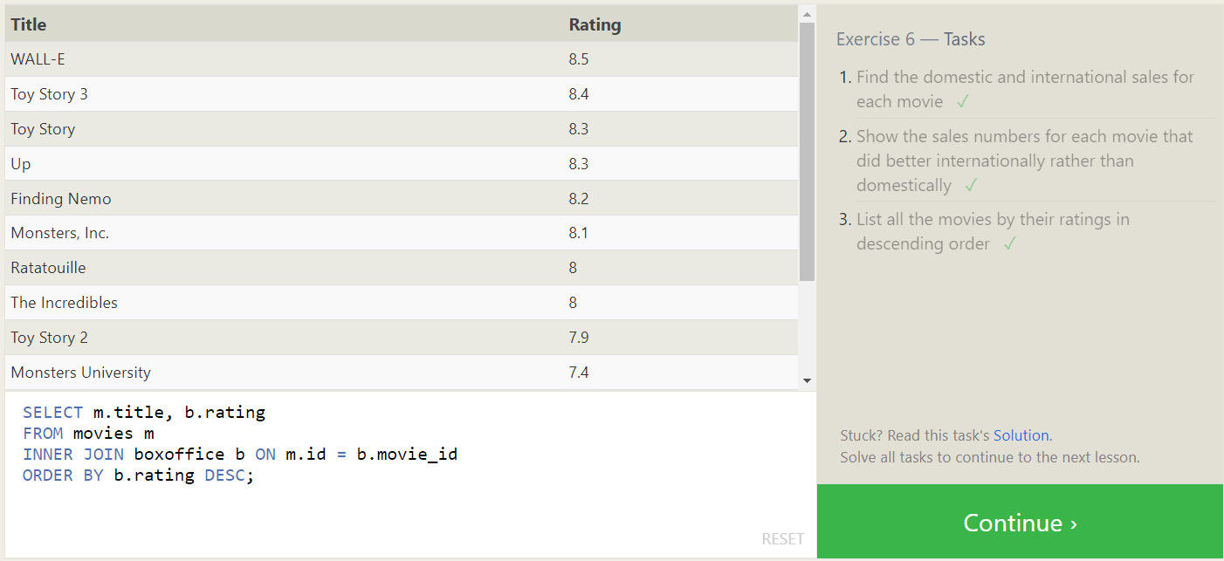

Exercise 6 — Tasks

**SQL Lesson 7: OUTER JOINs**

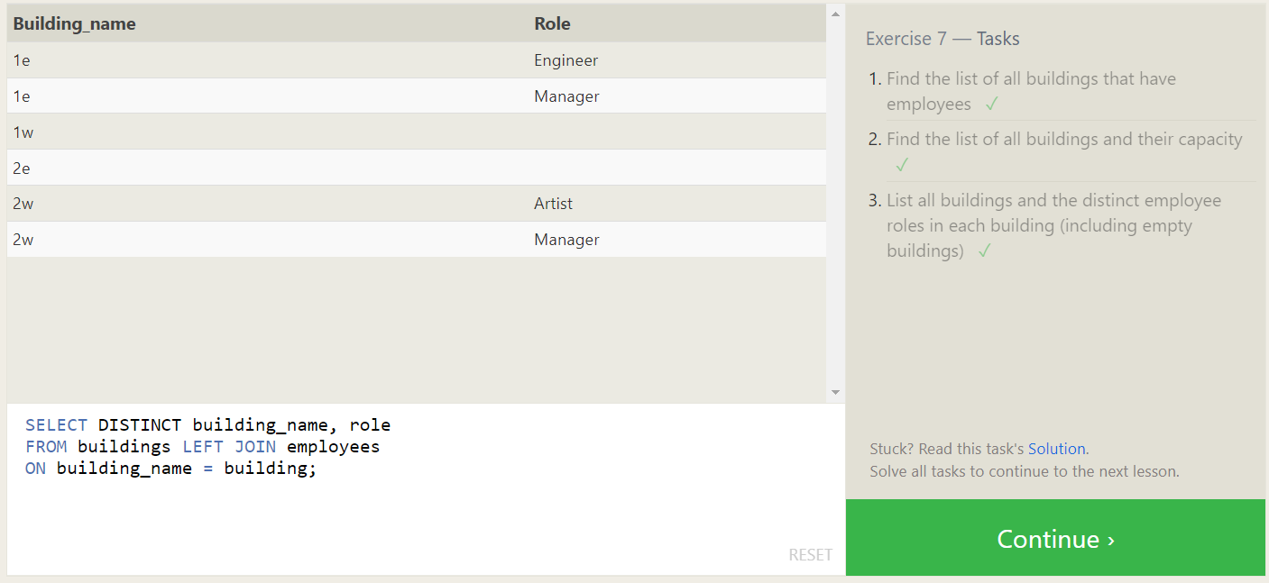

Exercise 7 — Tasks

**SQL Lesson 8: A short note on NULLs**

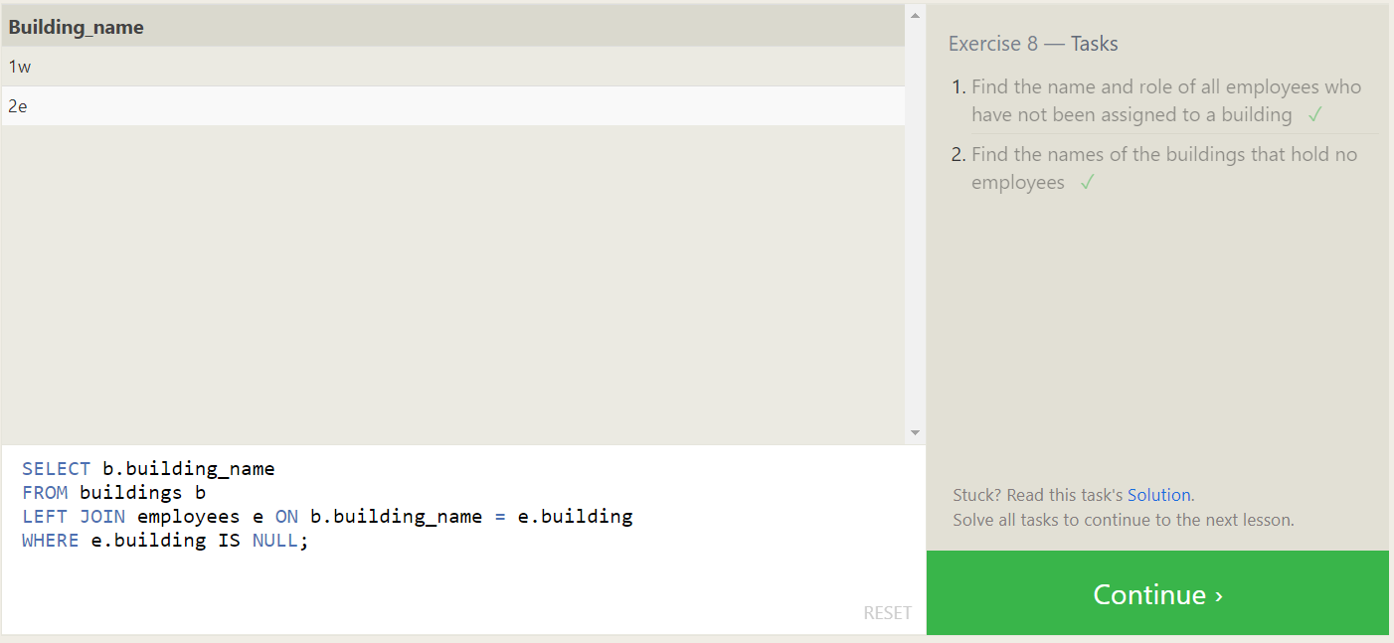

Exercise 8 — Tasks

**SQL Lesson 9: Queries with expressions**

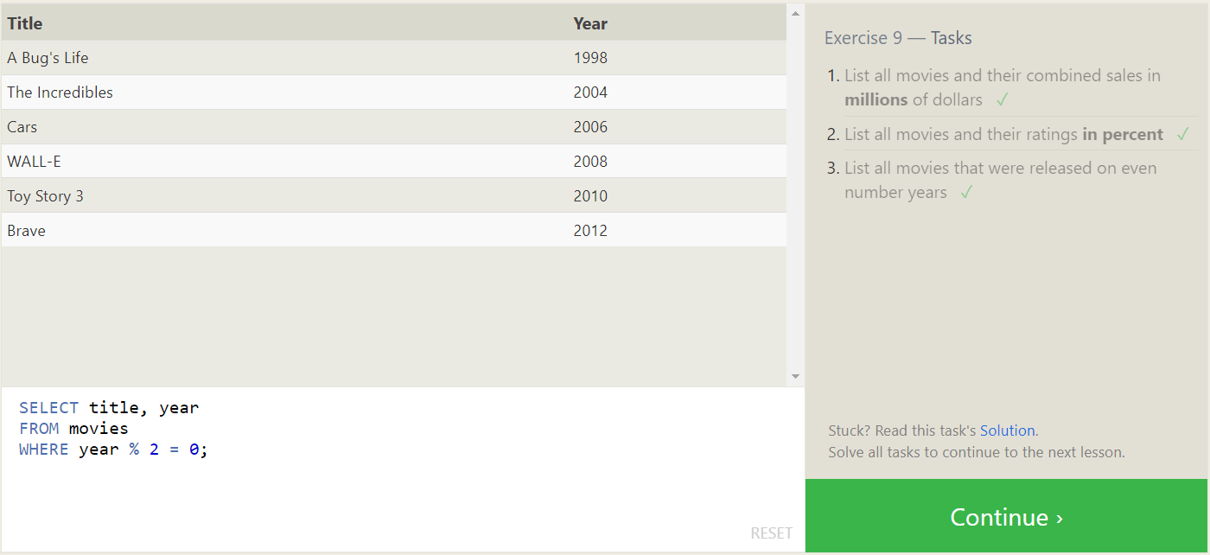

Exercise 9 — Tasks

**SQL Lesson 10: Queries with aggregates (Pt. 1)**

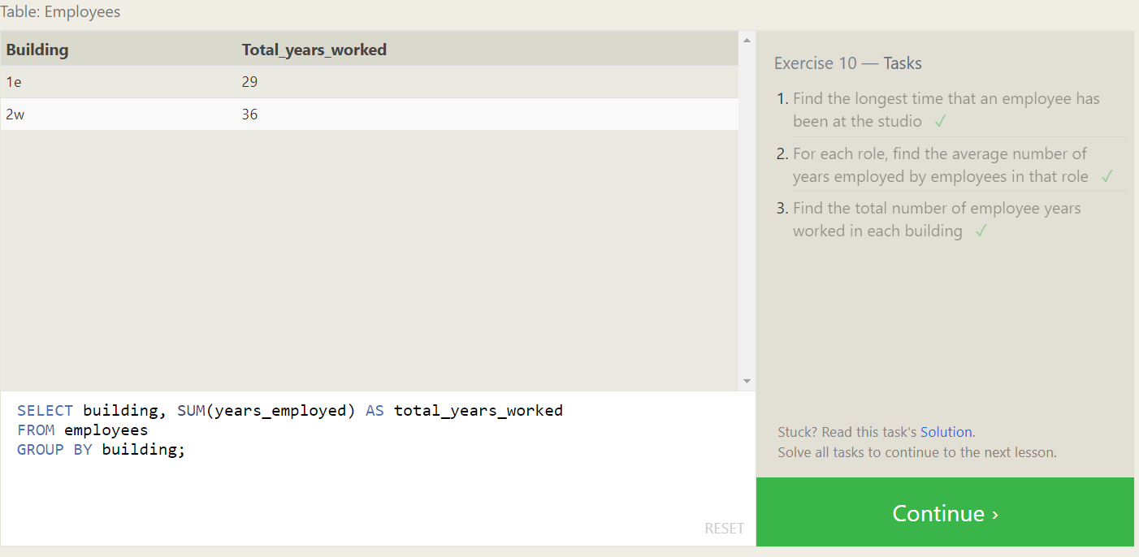

Exercise 10 — Tasks

**SQL Lesson 11: Queries with aggregates (Pt. 2)**

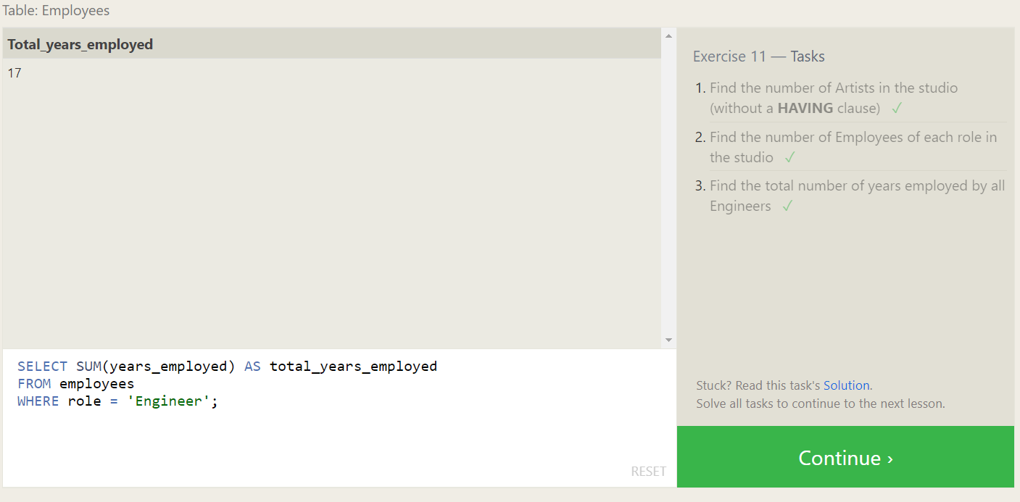

Exercise 11 — Tasks

**SQL Lesson 12: Order of execution of a Query**

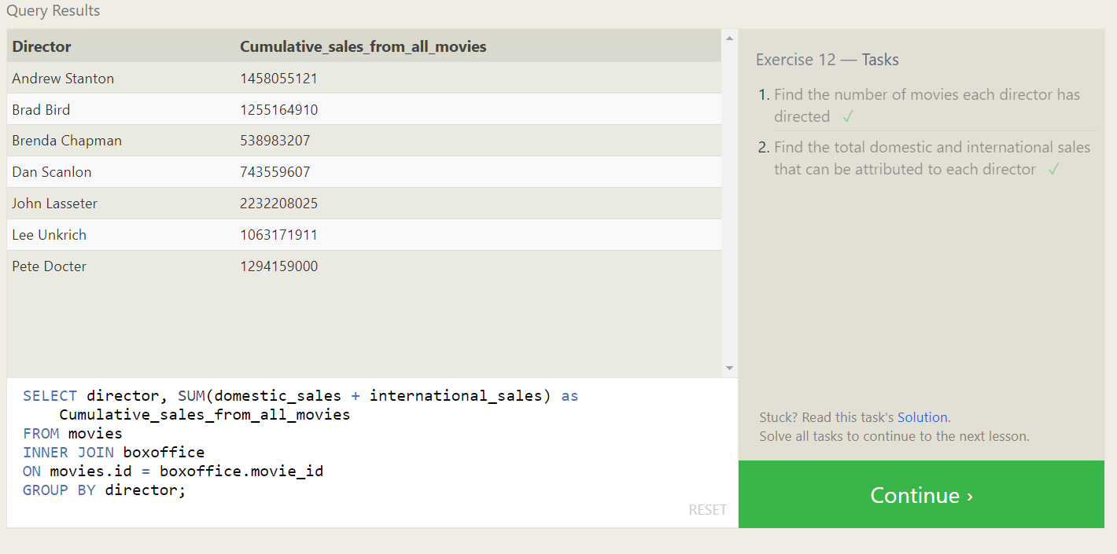

Exercise 12 — Tasks

**SQL Lesson 13: Inserting rows**

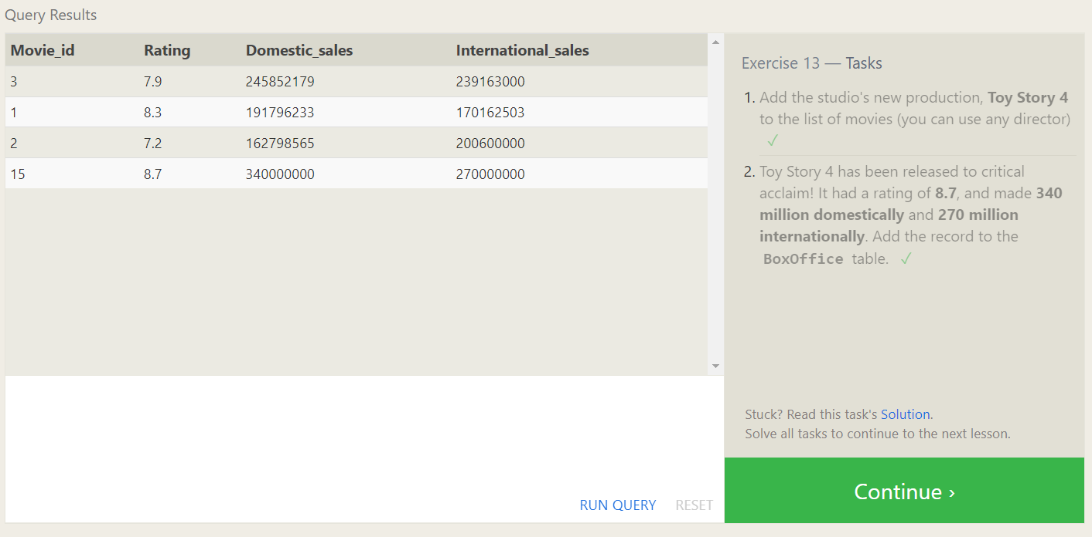

Exercise 13 — Tasks

**SQL Lesson 14: Updating rows**

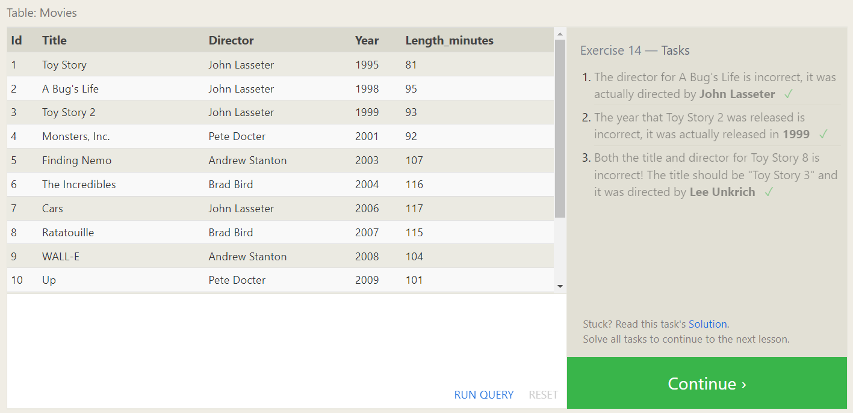

Exercise 14 — Tasks

**SQL Lesson 15: Deleting rows**

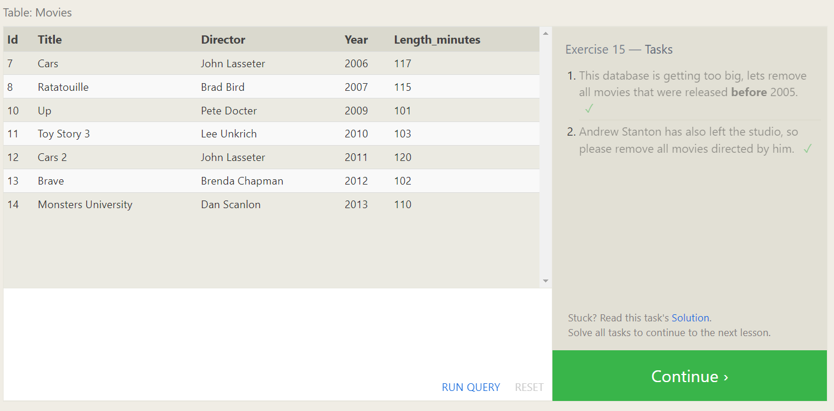

Exercise 15 — Tasks

**SQL Lesson 16: Creating tables**

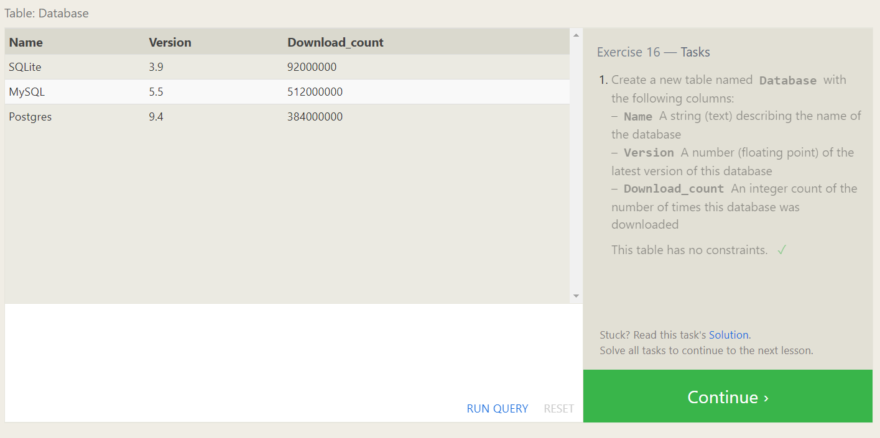

Exercise 16 — Tasks

**SQL Lesson 17: Altering tables**

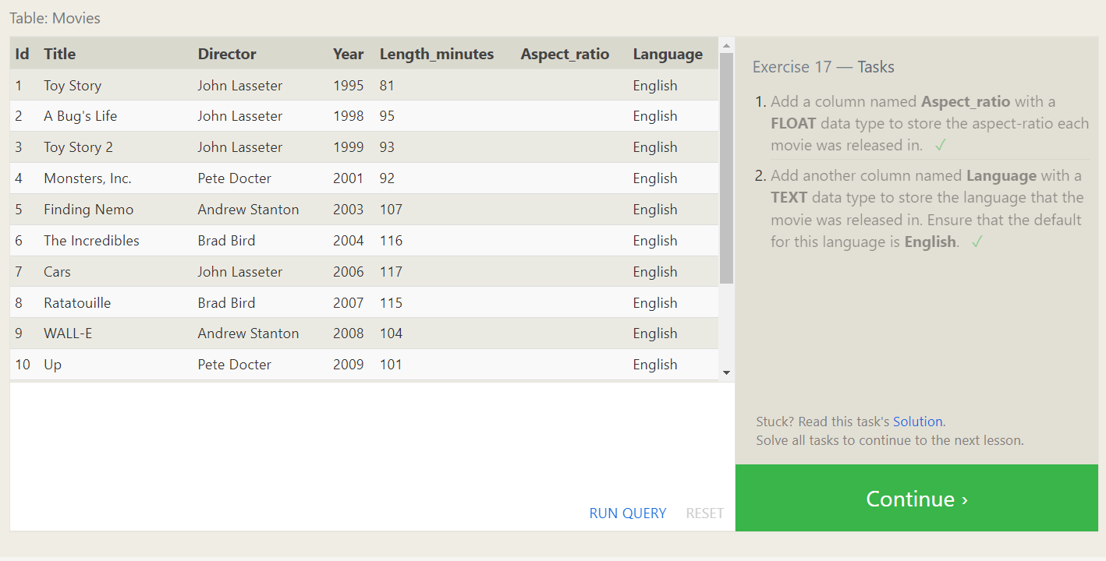

Exercise 17 — Tasks

**SQL Lesson 18: Dropping tables**

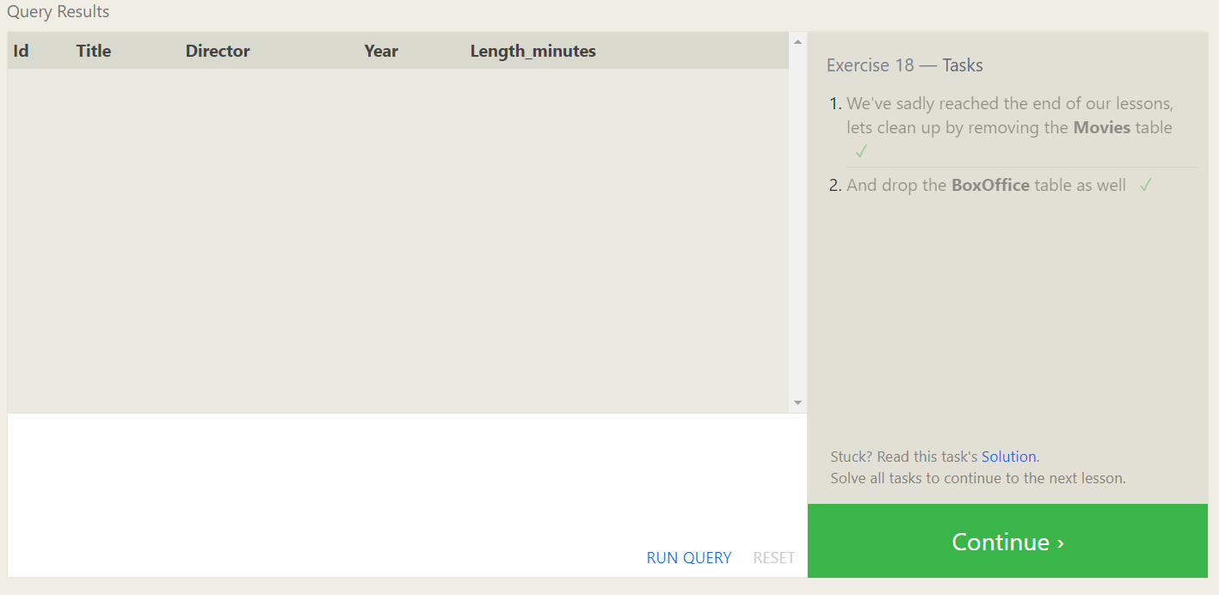

Exercise 18 — Tasks